IT24102268

Ps -lab 08

2)

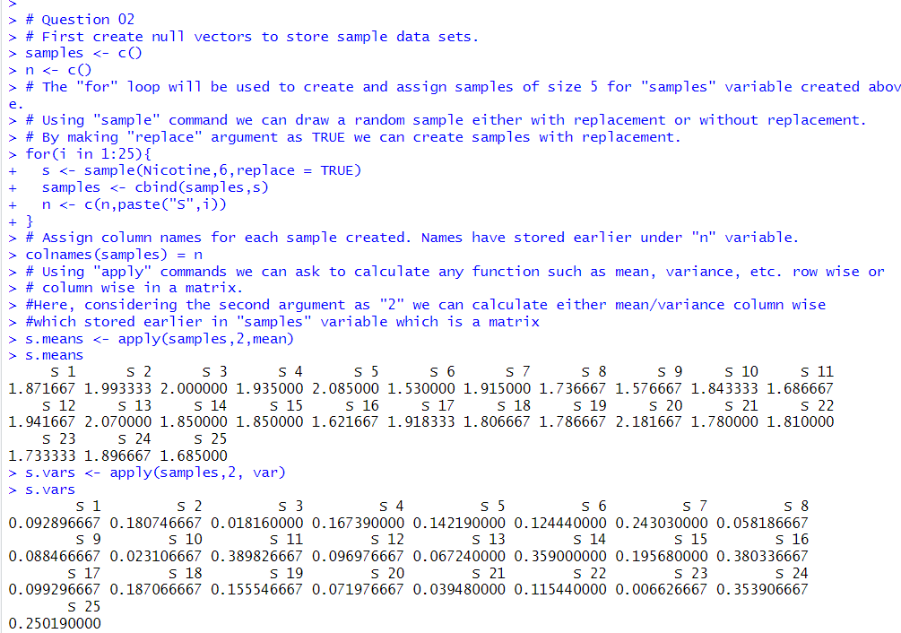

3)

